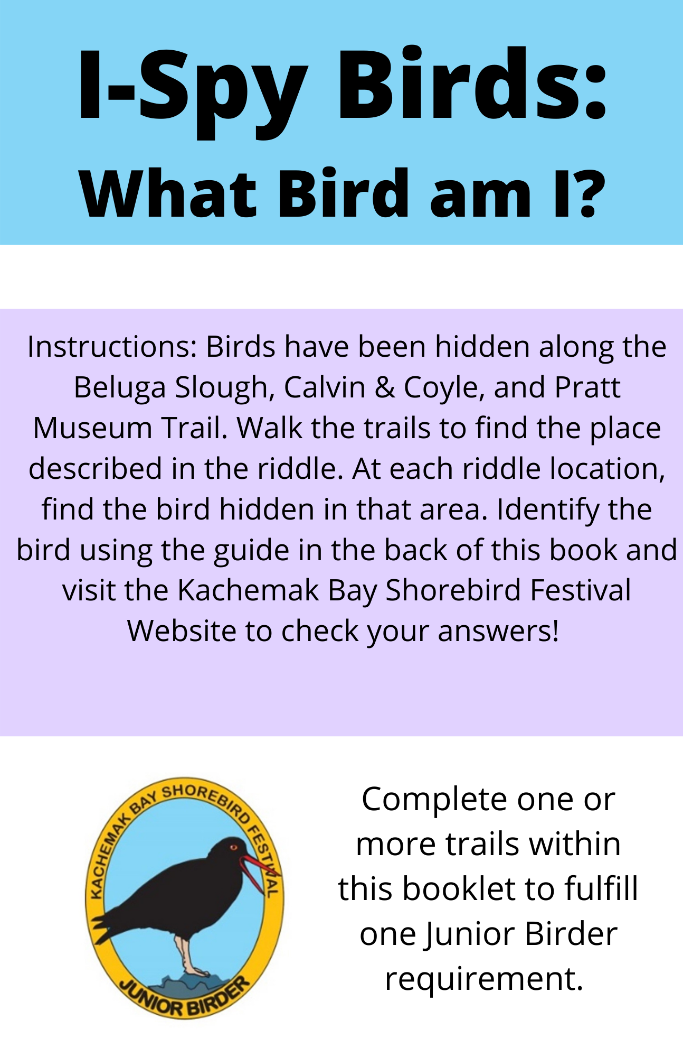 fdd

**Instructions:** Birds have been hidden along the local Calvin & Coyle, Karen Hornaday Park, and Poopdeck trails. While walking along these trails, look for the bright colored numbered flags. At each flag, a bird can be spotted. Once you have found a bird, use the guide for each trail to identify what species it is. Record that flag number next to the bird in your booklet. Use the Kachemak Bird List to determine what time of year that bird is usually seen here and how common they are.

**Pro tip:** You can use an additional bird identification tool such as a birding app or a bird identification guidebook to help I.D. the birds as you find them.

**(Visit the Kachemak Bay Shorebird Festival Website to check your answers.)**

https://kachemakshorebird.org/juniorbirder/

Bird Seek and Find:

Can you find the birds hiding in their habitats?

**Calvin and Coyle Trail**

Difficulty Level: Beginner

**20 Birds Total**

All birds hidden along this trail can be spotted locally in the Kachemak Bay area, however, **three** of these birds are invasive (meaning they are not originally from here and were introduced by people). After finding all the birds along this trail, can you guess which are the three invasive birds?

|  |  |  |  |
| --- | --- | --- | --- |
| **Flag #** | **Bird** | **What time of the year is this bird in Kachemak Bay?** | **Is it common here?** |
|  | Varied Thrush |  |  |
|  | Dark-eyed Junco |  |  |
|  | Belted Kingfisher |  |  |
|  | Merlin |  |  |
| **Flag #** | **Bird** | **What time of the year is this bird in Kachemak Bay?** | **Is it common here?** |
|  | Ring-necked Pheasant |  |  |
|  | Anna’s Hummingbird |  |  |
|  | Downy Woodpecker |  |  |
|  | Northern Shrike |  |  |
|  | Pine Grosbeaks |  |  |
| **Flag #** | **Bird** | **What time of the year is this bird in Kachemak Bay?** | **Is it common here?** |
|  | American Robin |  |  |
|  | Bank Swallow |  |  |
|  | White-winged Crossbill |  |  |
|  | Peregrine Falcon |  |  |
|  | Rock Pigeon |  |  |
| **Flag #** | **Bird** | **What time of the year is this bird in Kachemak Bay?** | **Is it common here?** |
|  | Alder Flycatcher |  |  |
|  | Black-backed Woodpecker |  |  |
|  | Pacific Wren |  |  |
|  | Northern Hawk Owl |  |  |
|  | Northern Goshawk |  |  |
| **Flag #** | **Bird** | **What time of the year is this bird in Kachemak Bay?** | **Is it common here?** |
|  | European Starling |  |  |

**Karen Hornaday Park Trail**

Difficulty Level: Intermediate

**10 Birds Total**

All birds hidden along this trail can be spotted locally in the Kachemak Bay area and are most commonly found in forested habitats. Many birds can be challenging to identify because they look similar (especially birds that belong to the same group). **When trying to identify a bird, be sure to look for details that make it unique or different than other birds that look similar to it.**

|  |  |  |  |
| --- | --- | --- | --- |
| **Flag #** | **Bird** | **What time of the year is this bird in Kachemak Bay?** | **Is it common here?** |
|  | Chestnut-backed Chickadee |  |  |
|  | Boreal Chickadee |  |  |
|  | Brown Creeper |  |  |
| **Flag #** | **Bird** | **What time of the year is this bird in Kachemak Bay?** | **Is it common here?** |
|  | American Pipit |  |  |
|  | Pine Siskin |  |  |
|  | Orange-crowned Warbler |  |  |
|  | Yellow Warbler |  |  |
|  | Townsend’s Warbler |  |  |
| **Flag #** | | **Bird** | **What time of the year is this bird in Kachemak Bay?** | **Is it common here?** |
|  | | Yellow-rumped Warbler |  |  |
|  | | Wilson’s Warbler |  |  |

**Poopdeck Trail**

Difficulty Level: Advanced

**10 Birds Total**

All birds hidden along this trail can be spotted locally in the Kachemak Bay area and are most commonly found in forested habitats. Many birds can be challenging to identify because they look similar (especially birds that belong to the same group). **When trying to identify a bird, be sure to look for details that make it unique or different than other birds that look similar to it.**

|  |  |  |  |
| --- | --- | --- | --- |
| **Flag #** | **Bird** | **What time of the year is this bird in Kachemak Bay?** | **Is it common here?** |
|  | Ruby-crowned Kinglet |  |  |
|  | Hermit Thrush |  |  |
|  | Brambling |  |  |
| **Flag #** | **Bird** | **What time of the year is this bird in Kachemak Bay?** | **Is it common here?** |
|  | Fox Sparrow |  |  |
|  | White-crowned Sparrow |  |  |
|  | Golden-crowned Sparrow |  |  |
|  | Savannah Sparrow |  |  |
|  | Song Sparrow |  |  |
| **Flag #** | **Bird** | **What time of the year is this bird in Kachemak Bay?** | **Is it common here?** |
|  | Lincoln’s Sparrow |  |  |
|  | White-throated Sparrow |  |  |

**See the map below for locations of each trail circled in yellow:**

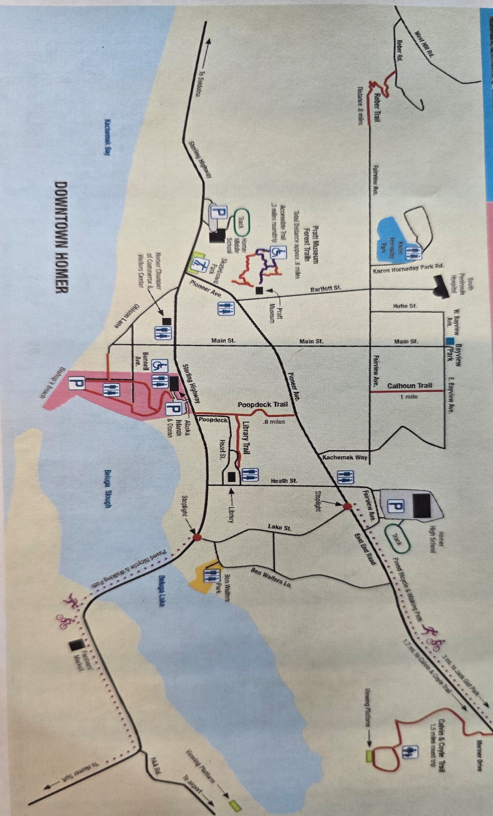

**Calvin & Coyle Trail**

**Karen Hornaday Park**

**Poopdeck Trail**